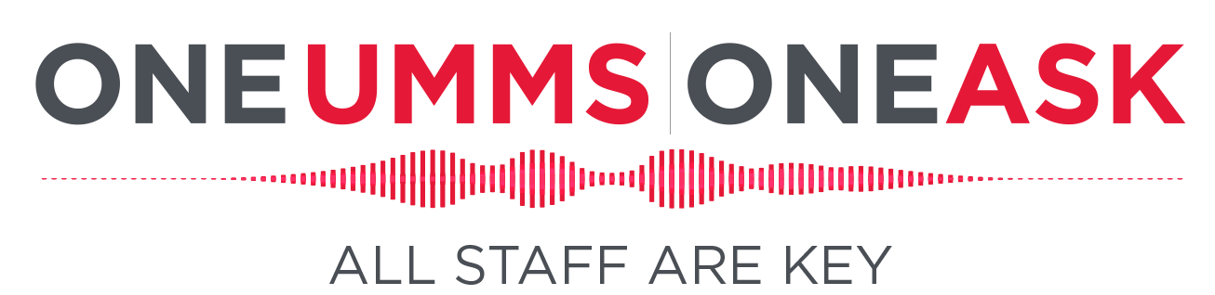

Ambassador/Manager Key Message Points
for Encouraging Participation
Not for distribution.

- Health care is personal.
The only way to improve the care we provide to our patients and the experience we create for our employees is to hear from the people who carry out our mission across our System. All staff are key.

- You’ll only be asked once.
The One UMMS | One ASK survey is a new, comprehensive survey for all UMMS employees and physicians. It combines the multiple surveys we conducted each year in the past into one comprehensive survey. These include engagement, safety and nursing MAGNET.

- Leaders are committed to listening to and acting on the results.
Leaders across our System seek to understand where transformation is needed and to create and sustain an engaged, patient-centered culture where all staff are key. One UMMS | One ASK is designed to deliver that understanding and, ultimately, a transformed One UMMS culture.

- Your responses are confidential.
UMMS hired an outside vendor to run the survey and provide us with data. Your individual responses will never be identified or revealed.

- Your voice is important.
This survey is a great way to have your voice heard at UMMS about critical issues. Nothing can change or improve unless you share your valuable perspectives.

- It’s easy to complete.
You’ll be able to take it anywhere, anytime from any device with internet access using a link that is all yours. Alternate options for completing the survey will be made available.

- I’m here if you have questions.
And you can find FAQs and more information at OneUMMS.org/oneask.

